Project Design Phase-II
Data Flow Diagram & User Stories

Date | 20 February 2026
Team ID | LTVIP2026TMIDS66673
Project Name | Plugging into the Future: An Exploration of Electricity Consumption Patterns Using Tableau
Maximum Marks | 4 Marks

Data Flow Diagrams:
A Data Flow Diagram (DFD) is a traditional visual representation of the information flows within a system. A neat and clear DFD can depict the right amount of the system requirement graphically. It shows how data enters and leaves the system, what changes the information, and where data is stored.
Example:
Example:
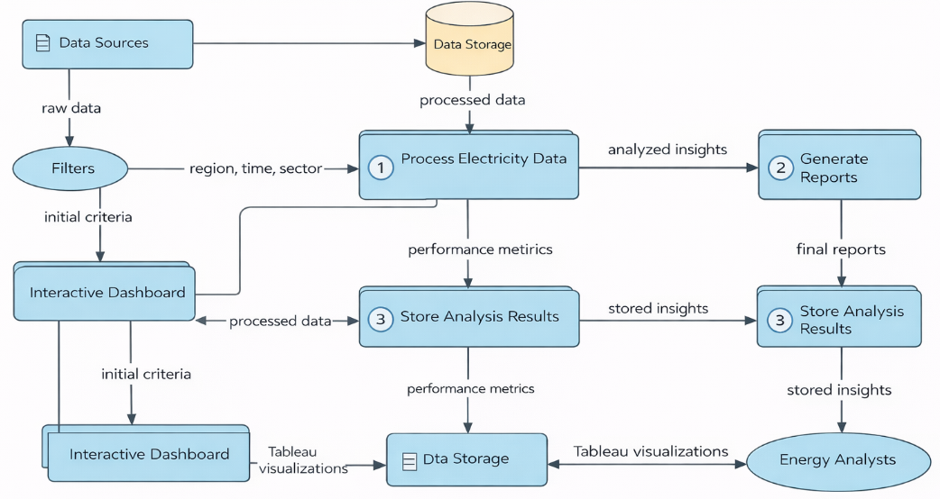
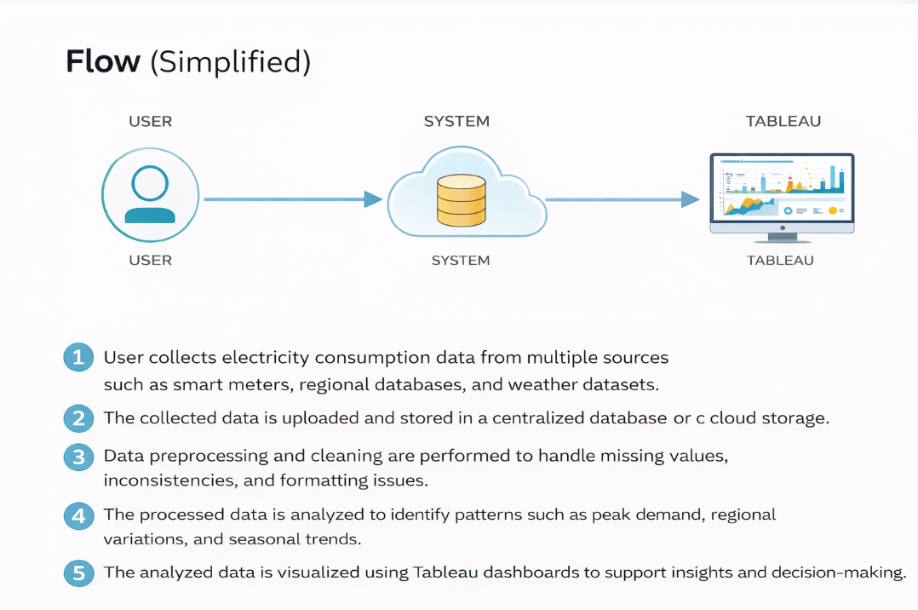

User Stories
User Type | Functional Requirement (Epic) | User Story Number | User Story / Task | Acceptance criteria | Priority | Release
Analyst (Web User) | Data Upload | USN-1 | As a user, I can upload electricity consumption datasets through the web interface. | Dataset uploads successfully without errors | High | Sprint-1
Analyst (Web User) | Data Validation | USN-2 | As a user, I can validate uploaded data for  missing or incorrect values. | Data quality issues are  highlighted | High | Sprint-1
Analyst (Web User) | Data Processing | USN-3 | As a user, I can process cleaned data  using backend services. | Data is processed and  stored correctly | High | Sprint-1
Analyst (Web User) | Dashboard | USN-4 | As a user, I can view interactive Tableau  dashboards showing electricity trends. | Dashboards load and  display insights | High | Sprint-1
Analyst (Web User) | Filtering | USN-5 | As a user, I can filter data by region, time,  and consumption type. | Filters update visualizations  instantly | Medium | Sprint-2
Analyst (Web User) | Insights | USN-6 | As a user, I can identify peak demand and  seasonal patterns. | Peaks and trends are  clearly visible | Medium | Sprint-2
Admin | Data Management | USN-7 | As an admin, I can manage datasets and  system configurations. | Admin can add/update/  remove data | Medium | Sprint-2
Stakeholder | Reporting | USN-8 | As a stakeholder, I can export dashboards or  reports. | Reports download  successfully | Low | Sprint-3

